SIMATS ENGINEERING
ASSESSMENT TOOL 1

COURSE NAME: CSA04 COURSE CODE: Operating Systems

COURSE OUTCOME COVERED

CO4: Optimize various file allocation strategies and disk scheduling algorithms to identify optimal methods for enhancing system performance.

Assessment Tool Weightage: 40%

QUESTIONS: 5 Total Marks:25

Annexure A

CODING CHALLENGE/HACKATHON

Code of Conduct:

I BP Venkata Uday Kumar 192411203 (Name / Reg No) certify that this submission is my original work and that I have adhered to the guidelines specified for this assessment.
I understand that any violation of academic integrity rules will result in disciplinary action.

UDAY KUMAR
Signature of the student:

Annexure A

CODING CHALLENGE

S.No | Coding Challenge Questions | Marks
1 | Write a program to simulate the three file allocation methods—Contiguous, Linked, and Indexed. The program should accept inputs including the total disk size (number of blocks), the file size(number of blocks required),and the allocation method (1forContiguous, 2for Linked, 3 for Indexed). Based on the selected method, the program must allocate disk blocks accordingly, display the allocated block numbers, and handle fragmentation scenarios, particularly when contiguous allocation fails due to insufficient continuous space. The output should show the list of allocated blocks or an appropriate error message if allocation is not possible. Ensure that built-in memory allocation functions are not used, and assume that disk blocks are numbered starting from 0. | 5
2 | Develop a program to manage free disk space using a bitmap technique. The program should accept inputs including the total number of disk blocks, the initial bitmap (where 0 represents free and 1 represents allocated), and a request for allocation specifying the number of blocks required. The program must identify and allocate free blocks efficiently, update the bitmap after allocation, and also support deallocation of specified blocks with appropriate bitmap updates.  The output should display the updated bitmap after allocation and deallocation operations.  Ensure that the program efficiently searches for free blocks and properly handles Cases where sufficient space is not available. | 5
3 | Implement a program that simulates at least three disk scheduling algorithms: FCFS, SSTF, and SCAN. The program should take as input the disk request queue, the initial head position, and the disk size. It must compute the total seek time for each algorithm, display the order in which disk requests are serviced, and compare their performance. The output should include the seek  sequence and total seek time for each algorithm, along with identification of the best- Performing algorithm based on minimum seek time. | 5
4 | Write a program to implement the C-SCAN and LOOK disk scheduling algorithms. The program should accept inputs including the request queue, the initial head position, and the direction of head movement (left or right). It must simulate both algorithms, calculate the total head movement required to service all requests, and compare their efficiency. The output should display the seek sequence, total head movement, and a conclusion indicating which algorithm performs better along with a brief justification. Optionally, the program may include a graphical visualization of head movement. | 5
5 | Design a program that integrates file allocation strategies with disk scheduling techniques to optimize system performance. The program should accept inputs such as the total number of disk blocks, file size (number of blocks required), disk request queue, initial head position, allocation method (Contiguous or Indexed), and disk scheduling method (FCFS or SSTF). It must allocate disk blocks based on the chosen allocation strategy, simulate disk scheduling to access the allocated blocks, calculate the total seek time, and compare performance across different combinations. The output should display allocated blocks, seek sequence, total seek time, and identify the best combination of allocation and scheduling methods. Ensure the program handles allocation failures, avoids duplicate block allocation, and maintains efficient scheduling. | 5

1.File Allocation: Contiguous, Linked, Indexed
Input: disk size, file size, allocation method.
For realistic fragmentation testing, the program also accepts the current disk bitmap (0 = free, 1 = occupied).
#include <stdio.h>

#define MAX 1000

void display(int blocks[], int n) {
int i;
printf("Allocated blocks: ");
for (i = 0; i < n; i++)
printf("%d ", blocks[i]);
printf("\n");
}

void contiguous(int disk[], int n, int fileSize) {
int i, j, start = -1, count;

for (i = 0; i <= n - fileSize; i++) {
count = 0;

for (j = i; j < i + fileSize; j++) {
if (disk[j] == 0)
count++;
else
break;
}

if (count == fileSize) {
start = i;
break;
}
}

if (start == -1) {
printf("Error: Contiguous allocation not possible.\n");
printf("There may be enough total free space, but no continuous space.\n");
return;
}

for (i = start; i < start + fileSize; i++)
disk[i] = 1;

printf("Contiguous Allocation Successful\n");
printf("Allocated blocks: ");
for (i = start; i < start + fileSize; i++)
printf("%d ", i);
printf("\n");
}

void linked(int disk[], int n, int fileSize) {
int blocks[MAX];
}
}

if (i == n) {
printf("Error: No free block available for index block.\n");
return;
}

disk[indexBlock] = 1;

for (i = 0; i < n && count < fileSize; i++) {
if (disk[i] == 0)
blocks[count++] = i;
}

switch (method) {
case 1:
contiguous(disk, n, fileSize);
break;

case 2:
linked(disk, n, fileSize);
break;

case 3:
if (fileSize + 1 > n) {
printf("Error: Indexed allocation requires an index block plus data blocks.\n");
} else {
indexed(disk, n, fileSize);
}
break;

default:
printf("Invalid allocation method.\n");
}

return 0;
}

Important fragmentation case
Suppose the disk is:
1 0 0 1 0 1 0 0 1
and the file requires 4 blocks.
There are enough free blocks overall, but there is no sequence of 4 consecutive free blocks, so Contiguous Allocation fails while Linked Allocation can succeed.
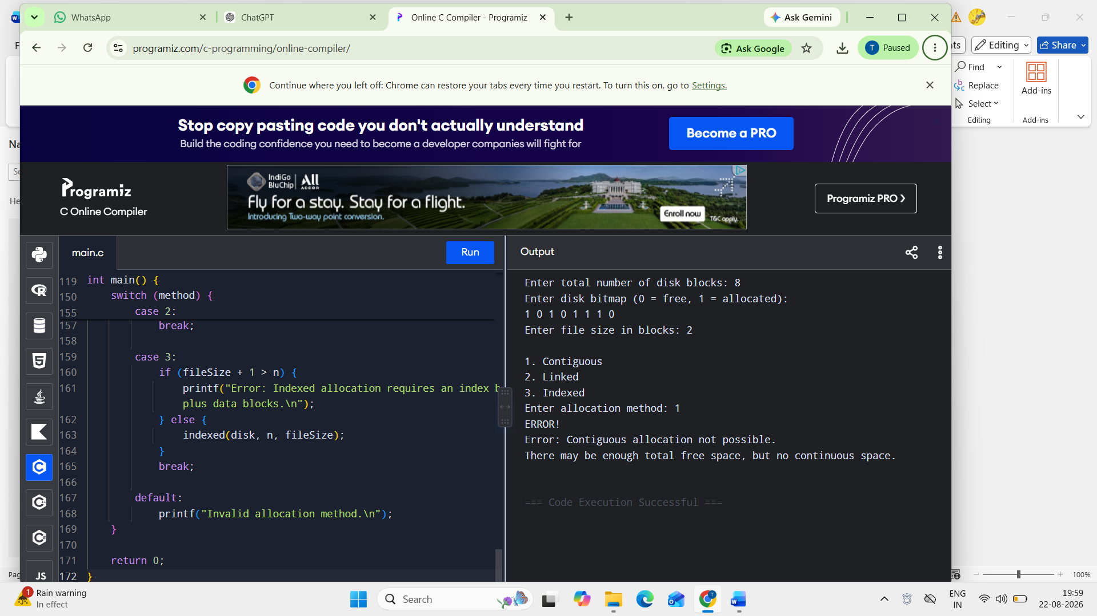

2. Bitmap Free-Space Management
This program supports both allocation and deallocation.
#include <stdio.h>

#define MAX 1000

void displayBitmap(int bitmap[], int n) {
int i;

printf("Bitmap: ");
for (i = 0; i < n; i++)
printf("%d ", bitmap[i]);

printf("\n");
}

void allocateBlocks(int bitmap[], int n, int request) {
int allocated[MAX];
int count = 0;
int i;

for (i = 0; i < n && count < request; i++) {
if (bitmap[i] == 0) {
bitmap[i] = 1;
allocated[count++] = i;
}
}

if (count < request) {
/* Roll back allocation */
for (i = 0; i < count; i++)
bitmap[allocated[i]] = 0;

printf("Error: Insufficient free space.\n");
return;
}

printf("Allocated blocks: ");
for (i = 0; i < count; i++)
printf("%d ", allocated[i]);

printf("\n");
}

void deallocateBlocks(int bitmap[], int n) {
int count, block, i;

printf("Enter number of blocks to deallocate: ");
scanf("%d", &count);

for (i = 0; i < count; i++) {
printf("Enter block number: ");
scanf("%d", &block);

if (block < 0 || block >= n) {
printf("Invalid block %d. Ignored.\n", block);
} else if (bitmap[block] == 0) {
printf("Block %d is already free.\n", block);
} else {
bitmap[block] = 0;
printf("Block %d deallocated.\n", block);
}
}
}

int main() {
int bitmap[MAX];
int n, request;
int i;

printf("Enter total number of disk blocks: ");
scanf("%d", &n);

if (n <= 0 || n > MAX) {
printf("Invalid disk size.\n");
return 0;
}

printf("Enter initial bitmap (0 = free, 1 = allocated):\n");
for (i = 0; i < n; i++) {
scanf("%d", &bitmap[i]);

if (bitmap[i] != 0 && bitmap[i] != 1) {
printf("Invalid bitmap value.\n");
return 0;
}
}

printf("\nInitial ");
displayBitmap(bitmap, n);

printf("\nEnter number of blocks required for allocation: ");
scanf("%d", &request);

if (request <= 0) {
printf("Invalid allocation request.\n");
return 0;
}

allocateBlocks(bitmap, n, request);

printf("After allocation:\n");
displayBitmap(bitmap, n);

deallocateBlocks(bitmap, n);

printf("After deallocation:\n");
displayBitmap(bitmap, n);

return 0;
} 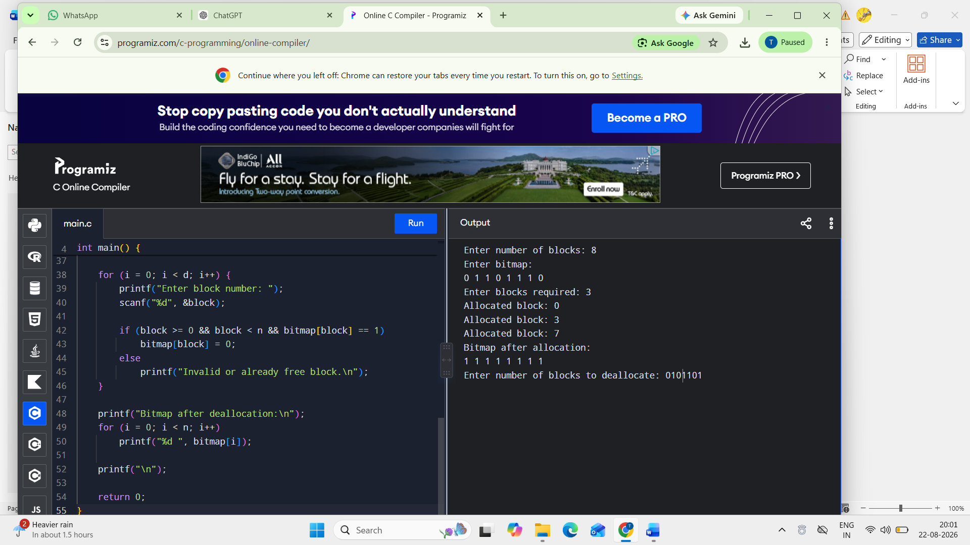

Complexity
The allocation search takes O(n) in the worst case and uses O(n) auxiliary space for storing the allocated block numbers.

3. FCFS, SSTF and SCAN Disk Scheduling
Here the disk cylinders are numbered:
0 to diskSize - 1
For SCAN, the head moves toward the specified direction and reaches the corresponding disk end before reversing.
#include <stdio.h>

#define MAX 1000

void copyArray(int source[], int dest[], int n) {
int i;
for (i = 0; i < n; i++)
dest[i] = source[i];
}

void fcfs(int requests[], int n, int head) {
int i, current = head;
int total = 0;

printf("\nFCFS\n");
printf("Seek sequence: %d ", head);

for (i = 0; i < n; i++) {
total += (current > requests[i])
? current - requests[i]
: requests[i] - current;

current = requests[i];
printf("-> %d ", current);
}

printf("\nTotal seek time: %d\n", total);
}

void sstf(int requests[], int n, int head) {
int visited[MAX] = {0};
int current = head;
int total = 0;
int completed = 0;
int i, best, distance, minDistance;

printf("\nSSTF\n");
printf("Seek sequence: %d ", head);

while (completed < n) {
best = -1;
minDistance = 1000000000;

for (i = 0; i < n; i++) {
if (!visited[i]) {
distance = current > requests[i]
? current - requests[i]
: requests[i] - current;

if (distance < minDistance) {
minDistance = distance;
best = i;
}
}
}

visited[best] = 1;
total += minDistance;
current = requests[best];

printf("-> %d ", current);

printf("Enter request queue:\n");
for (i = 0; i < n; i++)
scanf("%d", &requests[i]);

printf("Enter initial head position: ");
scanf("%d", &head);

printf("Enter disk size: ");
scanf("%d", &diskSize);

if (head < 0 || head >= diskSize) {
printf("Invalid head position.\n");
return 0;
}

for (i = 0; i < n; i++) {
if (requests[i] < 0 || requests[i] >= diskSize) {
printf("Invalid request: %d\n", requests[i]);
return 0;
}
}

printf("SCAN direction (1 = Right, 0 = Left): ");
scanf("%d", &direction);

if (direction != 0 && direction != 1) {
printf("Invalid direction.\n");
return 0;
}

fcfs(requests, n, head);
sstf(requests, n, head);
scan(requests, n, head, diskSize, direction);

return 0;
} 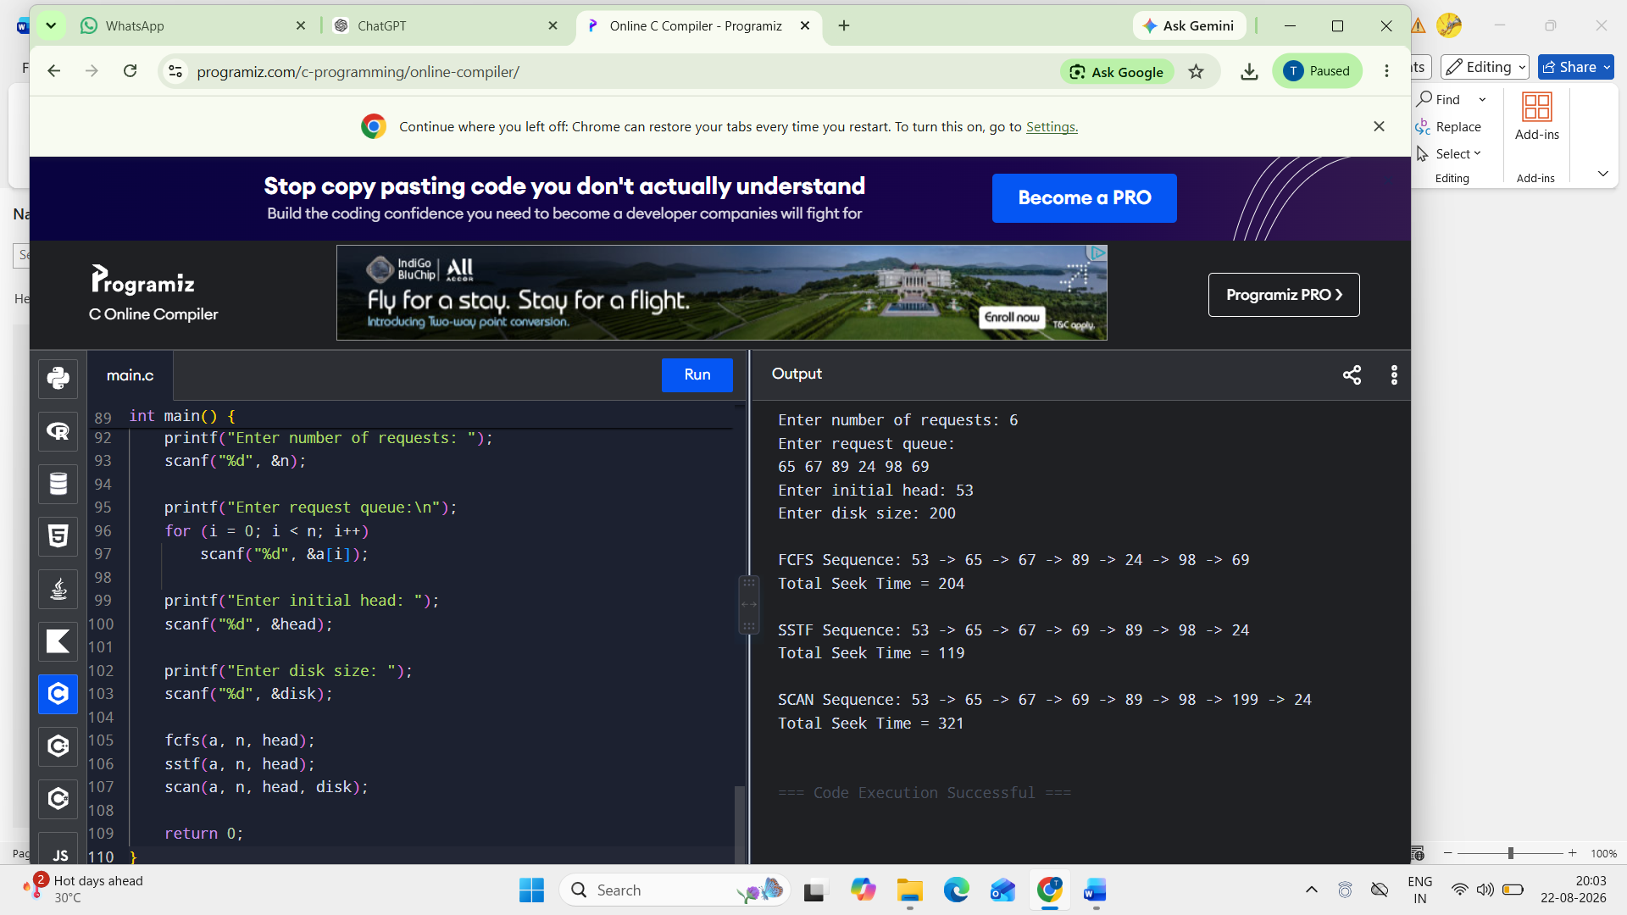

Comparison
The program prints the total seek time for all three algorithms. The algorithm with the smallest value is the best for that particular request sequence.
- FCFS: simplest, but may cause large head movements.
- SSTF: usually reduces seek time but can starve far-away requests.
- SCAN: provides more predictable service and avoids the worst starvation behavior of SSTF.

4. C-SCAN and LOOK
This version supports both left and right initial movement.
#include <stdio.h>

#define MAX 1000

void copyArray(int src[], int dest[], int n) {
int i;
for (i = 0; i < n; i++)
dest[i] = src[i];
}

void sort(int a[], int n) {
int i, j, temp;

for (i = 0; i < n - 1; i++) {
for (j = i + 1; j < n; j++) {
if (a[i] > a[j]) {
temp = a[i];
a[i] = a[j];
a[j] = temp;
}
}

scanf("%d", &requests[i]);

printf("Enter initial head position: ");
scanf("%d", &head);

printf("Enter disk size: ");
scanf("%d", &diskSize);

if (head < 0 || head >= diskSize) {
printf("Invalid head position.\n");
return 0;
}

printf("Enter direction (1 = Right, 0 = Left): ");
scanf("%d", &direction);

if (direction != 0 && direction != 1) {
printf("Invalid direction.\n");
return 0;
}

cscan(requests, n, head, diskSize, direction);
look(requests, n, head, direction);

printf("\nComparison:\n");
printf("LOOK generally performs fewer movements because it does not\n");
printf("travel to the physical end of the disk when no request exists there.\n");

return 0;
} 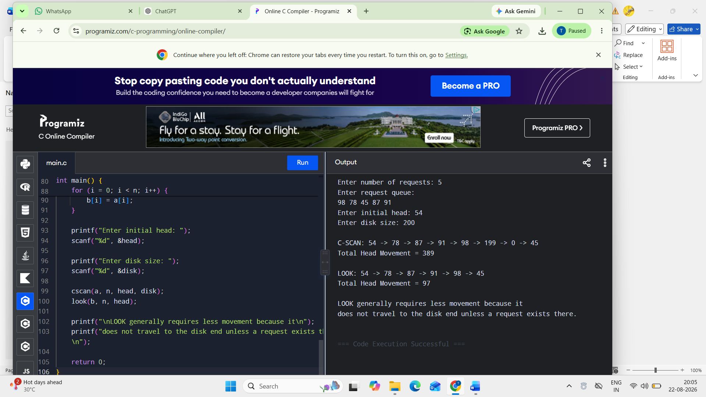

Key difference
C-SCAN
0 ------------------------------ MAX
↑
services requests
|
↓
reaches end
|
↓
jumps to 0
LOOK
0 ------------------------------ MAX
↑
reverses at the
last pending request
Therefore, LOOK often has lower head movement because it does not unnecessarily visit the disk's physical endpoints.

5. Integrated File Allocation + Disk Scheduling
This program supports:
- Contiguous allocation
- Indexed allocation
- FCFS scheduling
- SSTF scheduling
- Allocation failure detection
- Duplicate-free allocation
- Total seek calculation
- Comparison of all four combinations
#include <stdio.h>

#define MAX 1000

void copyArray(int src[], int dest[], int n) {
int i;

for (i = 0; i < n; i++)
dest[i] = src[i];
}

void contiguousAllocation(int disk[], int n,
int fileSize, int blocks[]) {
int i, j;
int count;

for (i = 0; i <= n - fileSize; i++) {
count = 0;

for (j = i; j < i + fileSize; j++) {
if (disk[j] == 0)
count++;
else
break;
}

if (count == fileSize) {
for (j = 0; j < fileSize; j++) {
blocks[j] = i + j;
total += requests[i] - current;
* ------------------------------------------------
*/

/*
* ------------------------------------------------
* INDEXED + FCFS
* ------------------------------------------------
*/
resetDisk(originalDisk, disk, n);

printf("\n========================================\n");
printf("INDEXED + FCFS\n");
printf("========================================\n");

if (indexedAllocation(disk, n, fileSize,
allocated, &indexBlock)) {

printf("Index block: %d\n", indexBlock);
printBlocks(allocated, fileSize);

fcfsTime = fcfs(allocated, fileSize, head);

} else {
printf("Indexed allocation failed.\n");
}

/*
* ------------------------------------------------
* INDEXED + SSTF
* ------------------------------------------------
*/
resetDisk(originalDisk, disk, n);

printf("\n========================================\n");
printf("INDEXED + SSTF\n");
printf("========================================\n");

if (indexedAllocation(disk, n, fileSize,
allocated, &indexBlock)) {

printf("Index block: %d\n", indexBlock);
printBlocks(allocated, fileSize);

sstfTime = sstf(allocated, fileSize, head);

} else {
printf("Indexed allocation failed.\n");
}

printf("\n========================================\n");
printf("PERFORMANCE COMPARISON\n");
printf("========================================\n");

printf("The combination with the smallest total seek time\n");
printf("provides the best disk-access performance for the\n");
printf("allocated file blocks.\n");

return 0;
}

One correction worth making for Question 5
The question gives two different request concepts:
- the general disk request queue, and
- the blocks allocated to the file.

RUBRICS FOR CALCULATION

Criteria | Weightage | Level 4 (Exemplary) | Level 3 (Proficient) | Level 2 (Developing) | Level 1 (Beginning)
Problem Understanding | 20% | Clearly understands problem  constraints, edge cases, and  competitive requirements | Understands problem with  minor gaps in constraints | Partial understanding; misses key constraints | Misinterprets problem or constraints
Algorithm | 25% | Selects optimal algorithm with best  time and space  complexity for competitive constraints | Uses efficient algorithm with  minor scope for improvement | Uses  basic/inefficient approach | No clear algorithmic approach
Code Implementation | 20% | Writes correct, efficient, and clean  code that passes all constraints | Code works with minor errors or inefficiencies | Partially correct code; fails for some cases | Code does not execute or  gives incorrect results
Competitive Performance | 20% | Solves problem within time limits  and handles large inputs effectively | Solves within acceptable time with minor delays | Struggles with time limits or larger inputs | Unable to solve within time constraints
Test Case Handling | 15% | Handles all test cases including  edge and hidden cases | Handles most test cases | Misses important edge cases | Fails on multiple test cases

